Lab report 01
Introduction to SPIM Simulator for the MIPS Assembly Language


Computer organization and Architecture
CSE 304L
Fall 2024

Submitted by: Naveed Ahmad
Registration No.: 22PWCSE2165
Class Section: B Semester :5th

“On my honor , as student of University of Engineering and Technology, I have neither given nor received unauthorized assistance on this academic work”

Student Signature: ____________

Submitted to:
Dr. Ammad Khalil
Oct 7, 2024

Department of Computer Systems Engineering
University of Engineering and Technology Peshawar

DIFFERENCE BETWEEN COMPUTER ORGANISATION AND ARCHITECTURE
Compute organization.
- Refer to the operational unit and they inter connection that relies on the architecture specification
- Deal with the physical and logical arrangement of hardware
- Focuses on the implementation of hardware and the physical system operation
Examples
- Control signal
- Interpret
- Memory hierarchy
- RAM size
- IOP devices
- Timers
Computer architecture.
- Refers to the abstract structure and behaver of the computer as seen by the programmers
- Focuses on the software interaction with the hardware and what functionality the hardware provides
- Involves the design and functional design of the system mainly from the programmers’ point of view
Examples
- Instruction set design
- Memory addressing
- Instruction execution
- CPU functionalities and capabilities
Types:
- CISC ARCHITECTURE
- CISC Stands for Complex Instruction Set Instruction
- Provides a rich set of instruction allowing the possessor to perform complex operation. In a single instruction the goal is to reduce the number of instructions per program for making each instruction more capable
- instruction more complex often performing multiple operation in a single instruction.
- Variable instruction length.
- Access the memory directly
- RISC
- Reduced Instruction Set Computing
- Simplify the instruction set of the CPU making each instruction in a single clock cycle
- RISC processors are highly pipelining
- Load and store
DIFFERENCE BETWEEN RISC AND CISC ARCHITECTURE:
RISC | CISC
Fewer and simple instruction | Many and complex instruction
Fixed instruction length | Variable instruction length
Each instruction executes in one cycle | Instruction can take multiple clock cycle
Load and store architecture | Direct memory access with most instruction
Highly optimised for pipelining | More difficult to pipelining due to complex city
Simple hardware with few transistor | More complex design
MIPS, arm, power PC | Intel

MIPs:
- Stand for micro processor without interlock pipeline stages
- Follow the RISC design principle
- MIPS processors are developed in early 1988
- Famous for their simplicity efficiency and pipeline design
- They are widely use in embedded system and high-performance application
- They are fixed length instruction
- Load store architecture
- Each register 32 bit

QtSpim simulator:
QtSPIM is a simulator that runs MIPS assembly language programs. It helps you understand how the MIPS processor works by simulating its operations.
KEY POINTS:
- Simulates MIPS Processor: QtSPIM simulates the behavior of a MIPS processor, which is commonly used in computer architecture education.
- Runs Assembly Code: You can write and run MIPS assembly language programs on it.
- Registers and Memory: It shows how data is stored in registers and memory when the program runs.
- Simple Interface: QtSPIM has a simple interface where you can load, run, and step through your assembly programs.
- Helps Debugging: You can find and fix errors in your code by observing the changes in registers and memory.

Source File Name:
- Here source file name is the name of the file where we write our MIPS assembly code. It usually ends with .asm or .s. we load this file into QtSPIM to run our program.

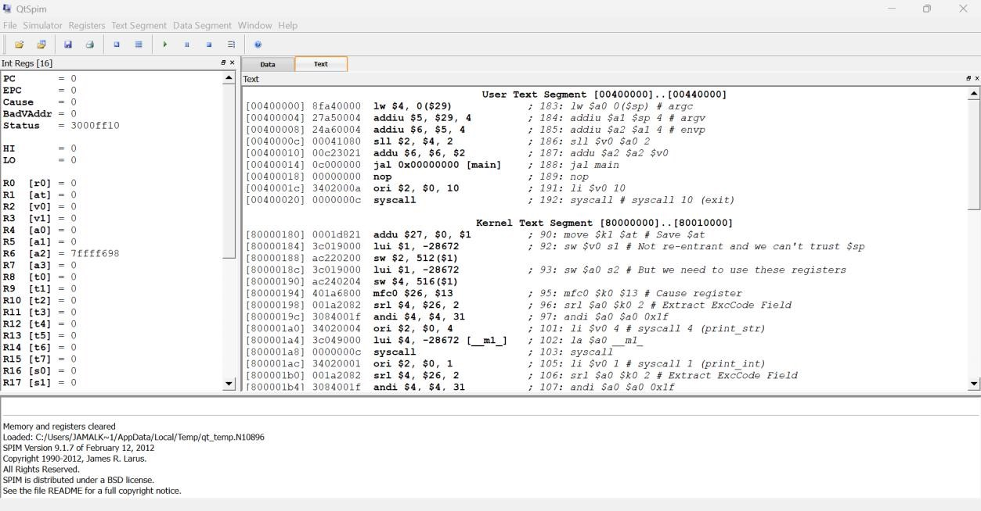

- In the QtSPIM screenshot, the Data and Text segments refer to different parts of memory where the program's components are stored:
TEXT SEGMENT (RIGHT SIDE):
- This section contains the program instructions, or the MIPS assembly code, that the CPU will execute. It’s the part where the logic of the program is defined (e.g., addiu, lw, syscall).
DATA SEGMENT:
- This section is not fully visible in the screenshot but typically holds the data the program uses, such as variables and constants. It includes static or global variables and memory used during program execution.

- QTsipm is used for MIPs architecture. QT refers to QT farmwork which is used for graphical user interface
- SIMPs is revers version of MIPs.
- In simple term computer architecture defines what a computer does while computer organization explains hoe it does it.

